2017 PRIMROSE TRAIL, CABERNET SAUVIGNON,

2019 Loose Moose, Old Vine Zinfandel

Lodi
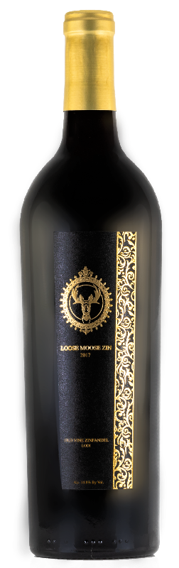

WINE SPECIFICATIONS:

UPC: 850021382056
Varietal Compositions: Old Vine Zinfandel
Appellation: Lodi
Alc. 14.8% By Vol.
SRP: $14.95
TASTING NOTES:

Vibrant ruby red color, aromas of red, black, and blue fruit tones. On the palate, ripe red berry and caramelized red cherry pie flavors accompanied by chewy ripe tannins that provide a welcome balance to the macerated fruit characteristics of the old vine grapes and a touch of warm spices on the lingering finish.

