95 Pts.  2017 Primrose Trail, Grand Reserve,  Pinot Noir, Sonoma Coast  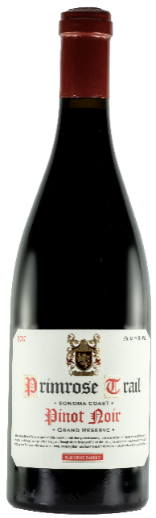  Review: A wine with a great balance between fruity and earthy components. Strawberry and black cherry lead the way, followed with notes of rhubarb, grilled herbs, and steeped black tea. Medium, heading into full bodied with a long, silky finish.  SRP: $40.00 |  | 95 Pts.  2017 Primrose Trail, Grand Reserve,  Pinot Noir, Sonoma Coast  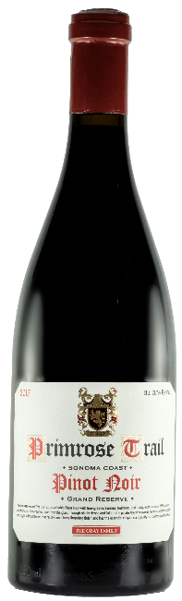  Review: A wine with a great balance between fruity and earthy components. Strawberry and black cherry lead the way, followed with notes of rhubarb, grilled herbs, and steeped black tea. Medium, heading into full bodied with a long, silky finish.  SRP: $40.00
95 Pts.  2017 Primrose Trail, Grand Reserve,  Pinot Noir, Sonoma Coast  Review: A wine with a great balance between fruity and earthy components. Strawberry and black cherry lead the way, followed with notes of rhubarb, grilled herbs, and steeped black tea. Medium, heading into full bodied with a long, silky finish.  SRP: $40.00 |  | 95 Pts.  2017 Primrose Trail, Grand Reserve,  Pinot Noir, Sonoma Coast  Review: A wine with a great balance between fruity and earthy components. Strawberry and black cherry lead the way, followed with notes of rhubarb, grilled herbs, and steeped black tea. Medium, heading into full bodied with a long, silky finish.  SRP: $40.00

