2017 PRIMROSE TRAIL, CABERNET SAUVIGNON,

2017 PRIMROSE TRAIL, GRAND RSV, PINOT NOIR Sonoma Coast

WINE SPECIFICATIONS:
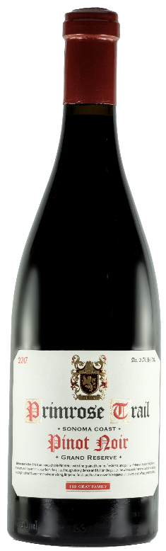
Vintage: 2017
Varietal Compositions: Pinot Noir
Appellation: Sonoma Coast
Alc. 13.7% By Vol.
SRP: $42.00
TASTING NOTES:

This approachable Pinot Noir with fine-grained tannins, freshness, and purity. Intense aromas of Bing cherry, strawberry and flower notes pour from the glass. Tough nicely dense and full on the palate, the wine avoids heaviness with fresh acidity and bright red fruit flavors that resolve on a long, lingering finish and has the essential elegance and purity that defines great Pinot Noir.

