2017 PRIMROSE TRAIL, CABERNET SAUVIGNON,

2018 LATITUDE 38, PRIVATE RESERVE, PINOT NOIR Sonoma County

WINE SPECIFICATIONS:

UPC: 850021382070
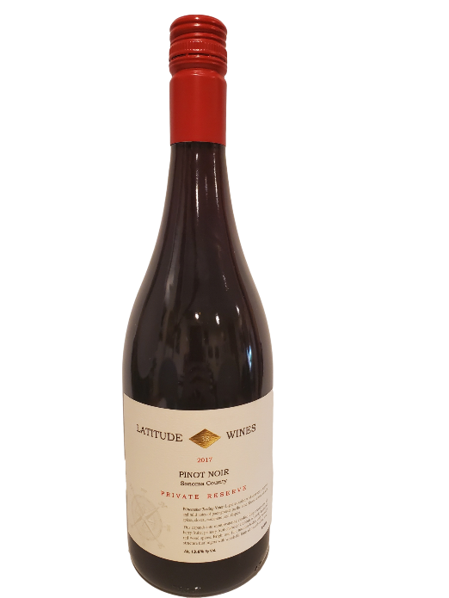
Varietal Compositions: 100% Pinot Noir
Appellation: Sonoma County
Alc. 14.3% By Vol.
SRP: $34.99
TASTING NOTES:

Light red color, wild strawberry, raspberry, and mild notes of pomegranate on the nose. Exotic aromas of Asian spices, cloves, cardamom, and allspice. Vibrant ruby color, inviting fresh aromas, bursting with ripe pomegranate, Bing cherry and plums. Fresh fruit forward with elegantly layered notes of ripe wild strawberry, raspberry, and baking spices accented by delicate acidity. A delicious clean and balanced finish.

